[5:-10] (array([-12.91273216, 19.20731395]), array([[ 0.00219651, -0.00786362],

[-0.00786362, 0.02826004]])) 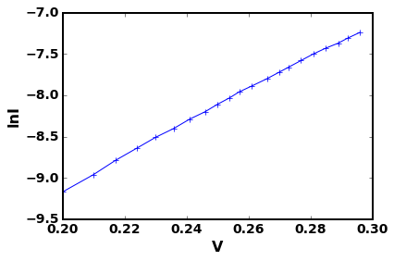

[6:-10] (array([-12.89882941, 19.15801172]), array([[ 0.00213722, -0.00764891],

[-0.00764891, 0.02747565]])) 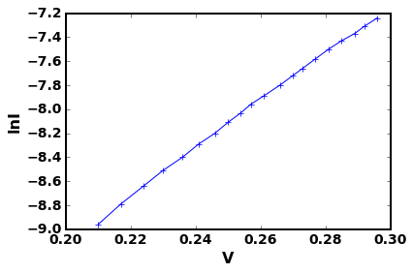

[7:-10] (array([-12.88259869, 19.10057996]), array([[ 0.00202761, -0.0072542 ],

[-0.0072542 , 0.02604503]])) 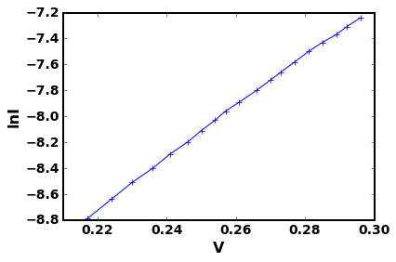

[8:-10] (array([-12.86659601, 19.0440308 ]), array([[ 0.00205349, -0.0073402 ],

[-0.0073402 , 0.02632465]])) 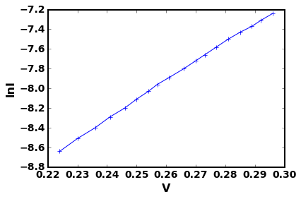

[9:-10] (array([-12.85141544, 18.99050167]), array([[ 0.00214581, -0.00766236],

[-0.00766236, 0.02744588]])) 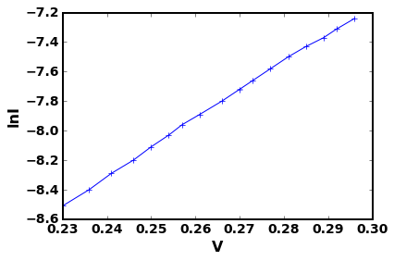

[10:-10] (array([-12.8359525 , 18.93607412]), array([[ 0.00235721, -0.00840503],

[-0.00840503, 0.03005434]])) 